MAJOR PROJECT II

MID-TERM REPORT

ON

Network Sniffer and Filtration

Submitted By-
Name | SAP ID | Branch
Aditya Upadhyay | 500052788 | CSE CCVT
Ankur Dubey | 500052611 | CSE CCVT
Archit Chaddha | 500052780 | CSE CCVT
Naman Jain | 500052648 | CSE CCVT

Under the guidance of
Mr. Vishal Kaushik
Assistant Professor
School of Computer Science


School of Computer Science
UNIVERSITY OF PETROLEUM AND ENERGY STUDIES
Dehradun-248007
January 2020

Approved By

Project Guide Department Head
(Mr. Vishal Kaushik) (Dr. Deepshikha Bhargava)
Department of Virtualization

 | Department of Virtualization  University of Petroleum and Energy Studies

Certificate

It is certified that the work contained in the project titled “Network Sniffer and Filtration” by following students has been carried out under my/our supervision and that this work has not been submitted elsewhere for a degree.

Student Name | Roll Number | Signature
1. Archit Chaddha | R110216036
2. Ankur Dubey | R110216025
3. Naman Jain | R110216099
4. Aditya Upadhyay | R110216014

Signature  (Mr. Vishal Kaushik)  Mentor  Department of Computer Engineering,  School of Engineering, U.P.E.S.  Dehradun, Uttarakhand  India-248007 | Signature  (Dr. Deepshikha Bhargava)  Head of the Department  Department of Computer Engineering,  School of Engineering, U.P.E.S.  Dehradun, Uttarakhand  India- 248007

Acknowledgements
We take this opportunity to express our sincere thanks to our supervisor Mr. Vishal Kaushik, Associate Professor, School of Computer Science, UPES Dehradun, for guidance and support. We would also like to express our gratitude towards her for showing confidence in us. It was a privilege to have a great experience working under her in a cordial environment.

We are grateful to all personnel who have facilitated and helped us in the understanding of our project.
We are also grateful to University of Petroleum and Energy Studies for providing us with an opportunity to pursue our project and for providing the necessary help whenever we needed. It is our radiant sentiment to place on record our best regards, deepest sense of gratitude to our batch mates for all the help and support provided by them, and also the Department of Virtualization, without whom, this project would not be possible.

Contents

Abstract
Acknowledgement

I. Introduction ....................................................................................... 5

II. Problem Statement............................................................................ 6

III. Objectives …..................................................................................... 7

IV. Literature Review…………………………………………………………………………… 7

V. Motivation ....................................................................................... 8

VI. Methodology…………………………………………………………………….………….. 8

VII. Screenshots.…………………………………………………………………….………..... 10

VIII. System Requirement ..................................................................... 14

IX. UML Diagrams …..……………………………………………………………...……….... 14

X. Schedule (PERT Chart) ……………………………………………………………………. 15

XI. References ……………………………………………………………………………….…… 15

School of Computer Science
University of Petroleum & Energy Studies, Dehradun

Mid-Term Report Submission (2020-21)

II
Major

Project Title: Network Sniffer and Filtration.

Abstract:
A port scanner is a piece of software designed to search a network host for open ports. The only way to track open ports is by using a port scanner, and the most accurate port scanner will be an online port scan. This project aims at the creation of a comprehensive application, which can be used at corporate environments. The port scanner and sniffer software are as simple as possible so that, it can be configured even by a non-technical person. This is often used by administrators to check the security of their networks and by hackers to compromise it. The main objective of this project is to scan the various ports within a specified range. With help of this administrator can easily identify the open ports and warn the clients. Packet sniffing is a technique of monitoring every packet that crosses the network. A packet sniffer is a piece of software that monitors all network traffic. The security threat presented by sniffers is their ability to capture all incoming and outgoing traffic, including clear-text passwords and usernames or other sensitive material.

- Introduction:
A sniffer (packet sniffer) is a tool that intercepts data flowing in a network. In the case of a sniffer, all traffic is shared when the sniffer software commands the Network Interface Card (NIC) to stop ignoring the traffic. The NIC is put into promiscuous mode, and it reads communications between computers within a particular segment. This allows the sniffer to seize everything that is flowing in the network, which can lead to the unauthorized access of sensitive data. Packet sniffing is commonly used by network technicians to diagnose network-related problems. Packet sniffers can also be used by hackers for less than noble purposes such as spying on network user traffic and collecting passwords.

The first step in any successful attack is sniffing, used to see what type of traffic is being passed on a network and to look for things like passwords, credit card numbers, and so forth. Sniffing is the term generally used for traffic monitoring within a network, while port scanning is used to find out information about a remote network. Both sniffing and port scanning have the same objective—to find system vulnerabilities—but they take different approaches. Sniffing is used by an attacker already on the network who wants to gather more information about the network. Port scanning is used by someone who is interested in finding vulnerabilities on a system that is unknown. A packet sniffer might be able to see traffic on an entire network or only a certain segment of it, depending on how the network switches are configured, placed, etc. On wireless networks, packet sniffers can usually only capture one channel at a time unless the host computer has multiple wireless interfaces that allow for multichannel capture. There are many tools available for network sniffing. Two of the most common tools are Ethereal and Snort. Both tools are relatively simple to use, and are designed to help troubleshoot problems, but can also be used to watch traffic. Prior to sniffing a network an attacker has to gain access. Attackers gain access by scanning devices on the network for vulnerabilities, then exploiting them. Port scanning can either be targeted or random. An attacker interested in a particular network will attempt to track down information about that network and scan for vulnerabilities. Alternatively, attackers will put large net blocks into a port scanner and let it run for days, trying to find any machine that is available and able to be exploited. This highlights the difference between an attacker and a script kiddie.

In this project, users are provided with three options, they can either sniff packets travelling in a network or they can filter packets or a user can exit. In case of sniffing packet, the details of packets are providing which includes details about version, header length, fragment, time to leave and many more related data. It also provides the details about the source ports and the destination ports etc. The second option provides user the utility to filter packets on according to the protocol such as ICMP (Internet Control Message protocol). The third option is for exiting of a user and no further sniffing occurs.

A packet sniffer is a useful tool to enable you to implement your company’s network capacity policy.

The main benefits are that they:

- Identify congested links
- Identify applications that generate the most traffic
- Collect data for predictive analysis
- Highlight peaks and troughs in network demand
- Network analyzer to monitor, analyze and troubleshoot your network.
- Traffic shaping through prioritizing application traffic
- Resizing subnets
- Rescheduling heavy-traffic events
- Limiting bandwidth for specific applications
- Replacing applications with more efficient alternatives.
- Mainly used by hackers in two forms:
    - Wire tappers to help steal data in transit
    - Man in the middle attacks that alter data in transit and divert traffic.

- Problem Statement:
When dealing with network problems, engineers usually follow standard tests to try to identify the source of the problem and make any necessary corrections. These tests usually involve checking the source (Client or Network device) IP address, Gateway, DNS server, Nslookup and performing a few ICMP Echo Requests (aka Ping) to verify connectivity with the local network and destination IP. These methods are usually enough to diagnose simple problems, but are clearly inadequate when dealing with complex network problems. This is where a high-quality network analyzer comes into play. Skilled Internet eavesdroppers use a technique called packet sniffing, which allows them to monitor all your activity without your knowledge or approval. Packet sniffing on networks (and the Internet) is like wiretapping phone lines.
Someone who is packet-sniffing as your data passes by them may be able to do all the following:
- Read all your emails.
- See all your passwords
- Know what websites you have visited
- See all the images from the websites you were on
- Capture account information (banks, credit cards) in detail
In all instances, the victims/targeted users don't know their communications have been tapped and compromised and that they're sharing their private information with a person, or a group of intruders. Hackers, on the other hand use packet-sniffing software (which is available free online!) to break into company networks and steal data. With it, they are virtually able to eavesdrop on any unencrypted information that's being exchanged between computers and traveling on a network.

- Objectives:
• To implement an extensive analysis of packets in order to get detailed information about packets.
• To filter information of packets based on different protocols.
• To implement User friendly user interface for selection of functionality.
- Literature Review :
- An Approach to Detect Packets Using Packet Sniffing by Rupam, Atul Verma, Ankita Singh:
This paper proposes an approach to detect packets through packet sniffing. It includes some negative aspects but besides these negative aspects, it is much useful in sniffing of packets. Packet sniffer is not only used for hacking purpose but also it is used for network traffic analysis, packet/traffic monitoring, troubleshooting and other useful purposes. Packet sniffer is designed for capturing packets and a packet can contain clear text passwords, user names or other sensitive material. Sniffing is possible on both non switched and switched networks. We can use some tools to capture network traffic that are further used by researchers.
- Analysis of Network Traffic by using Packet Sniffing Tool: Wireshark by Praful Saxena, Sandeep Kumar Sharma:
Packet sniffing is useful to analyze the data during the Transmission in the network. Networks Sniffing in non-switched network is easy but sniffing in switched network is difficult because we use switches in network which narrow the traffic and send to particular system, so for sniffing in this type of network we use some methods. Packet sniffer can be enhanced in future by Incorporating features like making the packet sniffer program platform independent, and making tool by neural network Hence, Sniffing should done in a manner to improve the performance of the network and to make it more secure .
- A study reports from Frieden (2008) show that network service providers are willing to pay for packet sniffing enhancements that provide more protection, privacy and reliability. In a bid to accommodate an increasing demand for higher bandwidths and less tolerance for dropped, delayed or lost packet delivery, equipment that can examine and prioritize internet traffic at an increasingly granular level and inspect network traffic on a packet-by-packet basis are being developed. As such, network service providers now diversify service based on allocated bandwidth, routing priority and performance guarantees. Packet sniffing in this case also entails actively examining packet headers that provide traffic routing information and identify content characteristics contained thereof in the packet sniffed.

- Motivation:
In the recent times, we have seen a massive need for cyber security awareness. As, people perform almost all their day-to-day activities online, it brings intense threat to their personal space and privacy. Data in today’s world has enormous importance and the one owning that data can make or destroy lives. That is the power Data holds in this era. By looking at the current trends of cyber-crimes and frauds, we decided to study and develop a product to prevent such criminal activities from happening in the near future.

- Methodology:
This project is developed using Waterfall Model as the SDLC. The prototype model is the most suitable for a project like this as a prototype (i.e. a working model) can be released in the market as Beta version of the software and the users can use it and suggest the changes which can improve the software. This leaves the chance for optimizing the software so that it delivers all the functionalities it lists and all the bugs, problems and inefficiencies are targeted and mended. Since this type of project is new in the market, therefore the outcomes are not fixed, they vary on how the user takes the software product, this is also the reason prototype model must be used. As the basic idea in Prototype model is that instead of freezing the requirements before a design or coding can proceed, a throwaway prototype is built to understand the requirements. This prototype is developed based on the currently known requirements. The interactions with prototype can enable the client to better understand the requirements of the desired system. Prototyping is an attractive idea for complicated and large systems for which there is no manual process or existing system to help to determine the requirements. This application is designed into different modules:

- Packet Sniffing
- Packet Filtering

Packet Sniffing:
In order to proceed with packet sniffing, raw data of Ethernet packets is analyzed from the socket. Then, different type of protocols such as ICMP, TCP, IPV4, etc. are identified. Once they are identified, then the packet is filtered according to its particular headers and address length. As the data packet stream keep incoming, the packets are gone through the same process and displayed according to their protocols in the same order. In order to classify the packets further, they are shown in two unpacking modes: Briefly and Verbosely. In briefly option, the source to destination address along with the protocol details are shown, while the verbosely option shows every attribute of the packet. Alongside, whenever one tries to exit the program, there is always an option to save all the packets that are sniffed. So that, the same file can be used for further processing.

Packet Filtering:
Under packet filtering, one has option to either open the previously sniffed packets or have a filter option on the packets that are currently being sniffed. The previously sniffed packets that are stored in the files are loaded and then according to protocol, depth or packet number, that packets can be analyzed. If they have to be analyzed from the running stream, one can select the number of filters and then according to the running stream, the packets that will match the above conditions will be displayed. And if one wants to, he can save that file which contains those filtered packets.

The flowchart describes the working of network scanning and sniffing through a flowchart. The user has the option to sniff packets or filter packets. Sniffing of packets start at the moment the user selects that option, while the filtering of packets needs the sniffing to be already running. Moreover, it can filter the previously stored packets from the saved results or some external source in case forensics needs to be done, according to the user needs. Both the concurrent options have further saving or exiting options.

- ALGORITHM
1. Sniffing-

Step 1: Start
Step 2: Turn NIC to promiscuous mode.

Step 3: Create a socket with following parameters-
- Packet Interface – PF_Packet
- Raw packet identifier
- Protocol
s = socket.socket(socket.AF_INET, socket.SOCK_RAW, socket. htons(0x0800))

Step 4: Function recvfrom() is needed to be called in order to receive the packet.
while True:
packet = s.recvfrom(2048)

Step 5: Ripping off the Ethernet header
ethernet_header = packet[0][0:14]

Step 6: Parsing and unpacking header with struct method
eth_header = struct.unpack("!6s6s2s", ethernet_header)

Step 7: Retrieve MAC Address for both destination and source of packet.
print "Destination MAC:" + binascii.hexlify(eth_header[0]) + " Source MAC:" + binascii.hexlify(eth_header[1]) + " Type:" + binascii.hexlify(eth_header[2])

Step 8: Get the IP Header for the concerned Packet.
ipheader = pkt[0][14:34]
ip_header = struct.unpack("!12s4s4s", ipheader)
print "Source IP:" + socket.inet_ntoa(ip_header[1]) + " Destination IP:" + socket.inet_ntoa(ip_header[2])

Step 9: Save the received content of packets in a file
Step 10: Exit.

2. File Find

Step 1: Start
Step 2: Define the folder where all the pre-fetched files are stored.
Step 3: Give the name of file.
Step 4: Check for file name in the folder.
Step 5: if file exists:
Print “file exists”
Else
Print “file does not exists”

- Screenshots:

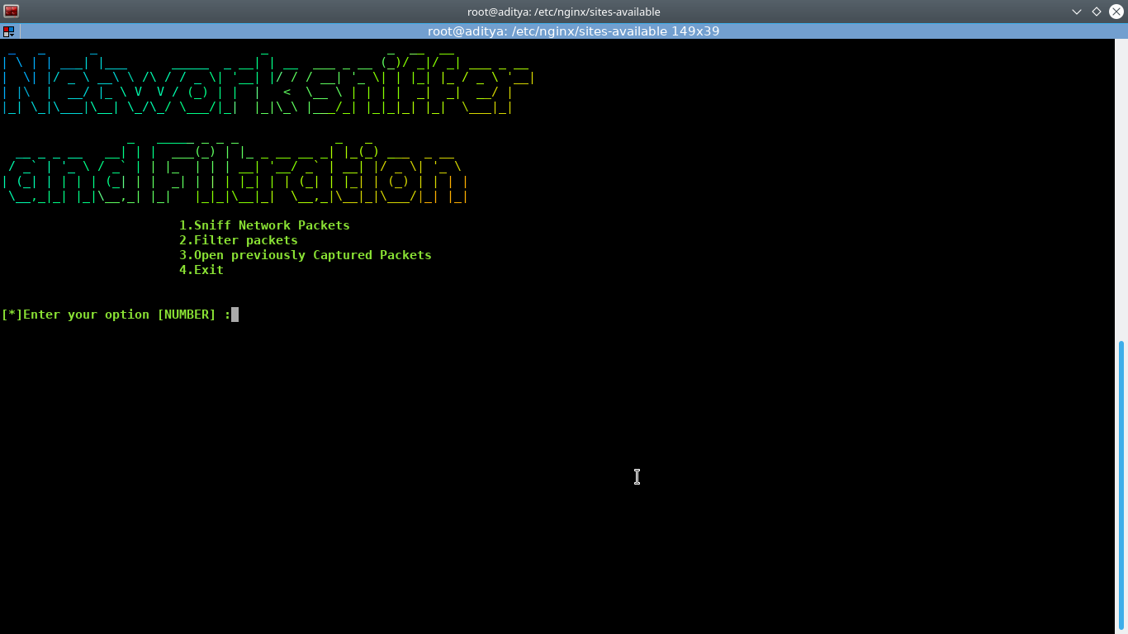
Figure 1. Menu Page

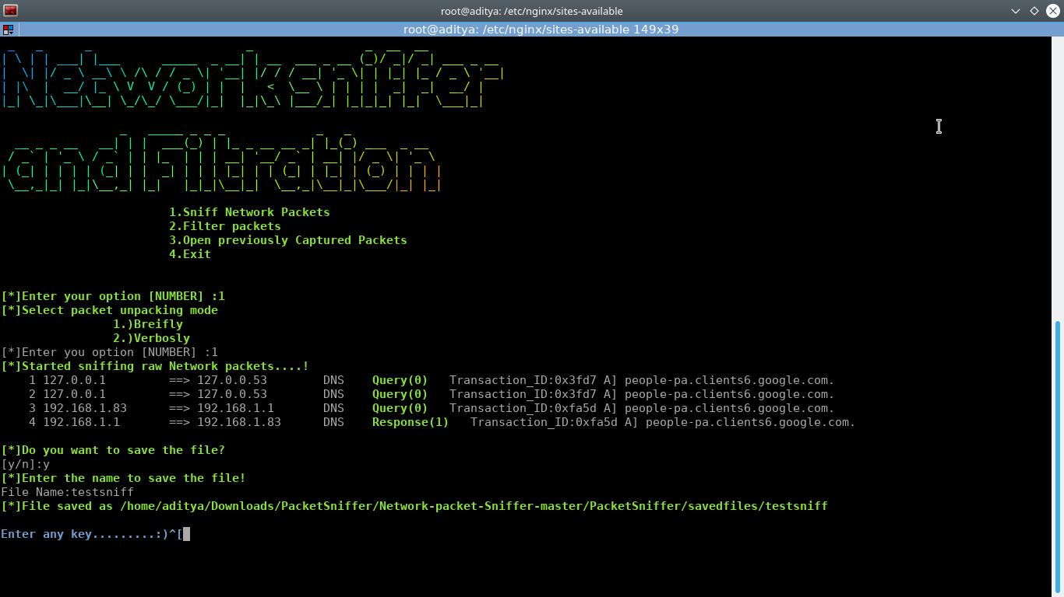

Figure 2. Sniffing with Briefly mode

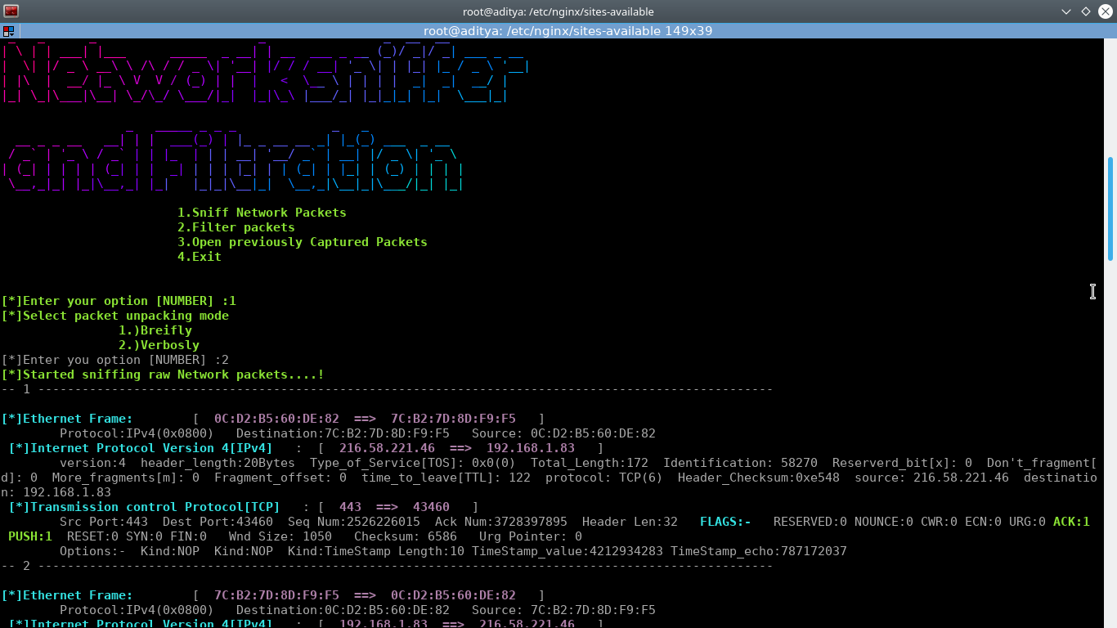

Figure 3. Sniffing with Verbosely mode (output 1)

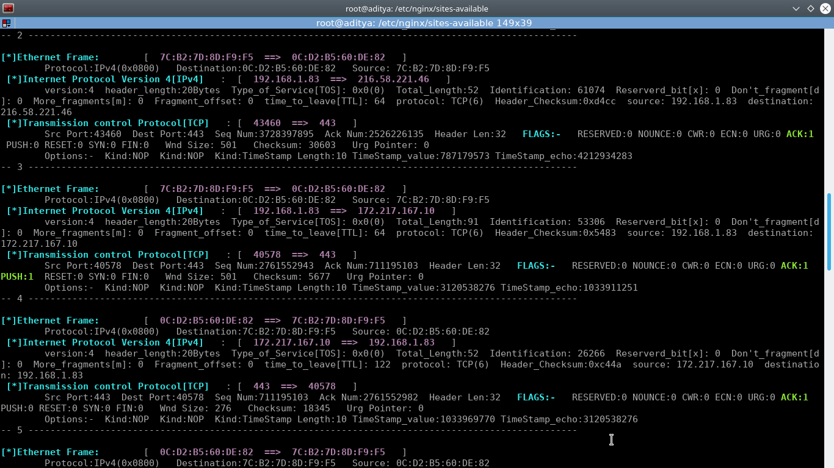

Figure 4. Sniffing with Verbosely mode (output 2)

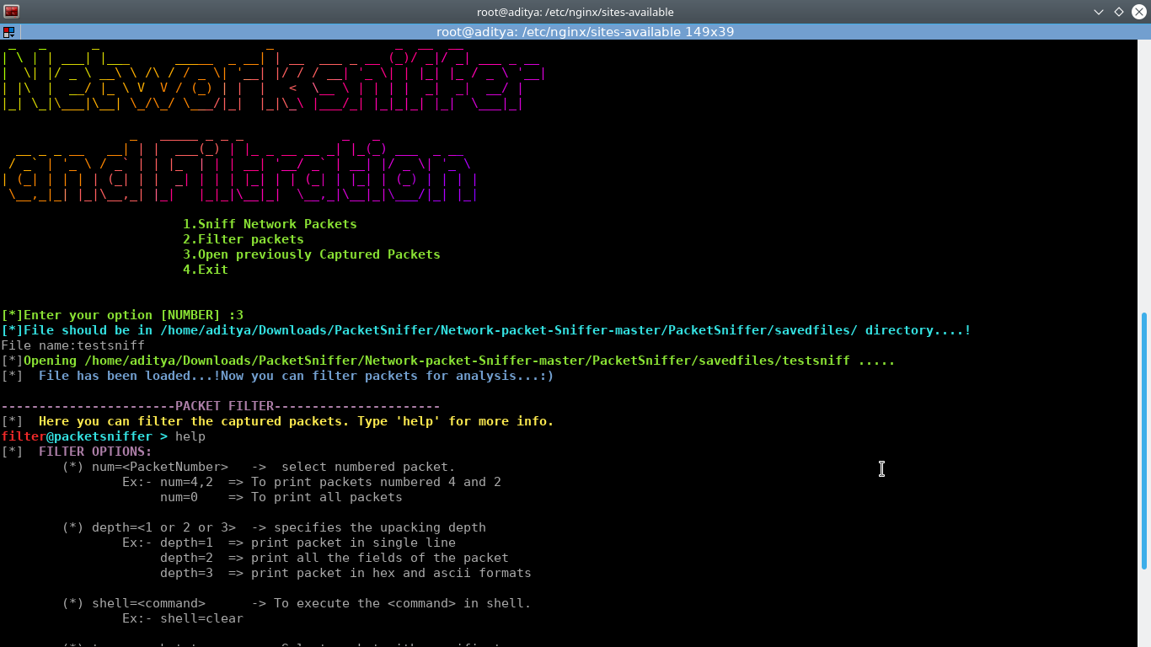

Figure 5. Open previously captured packets

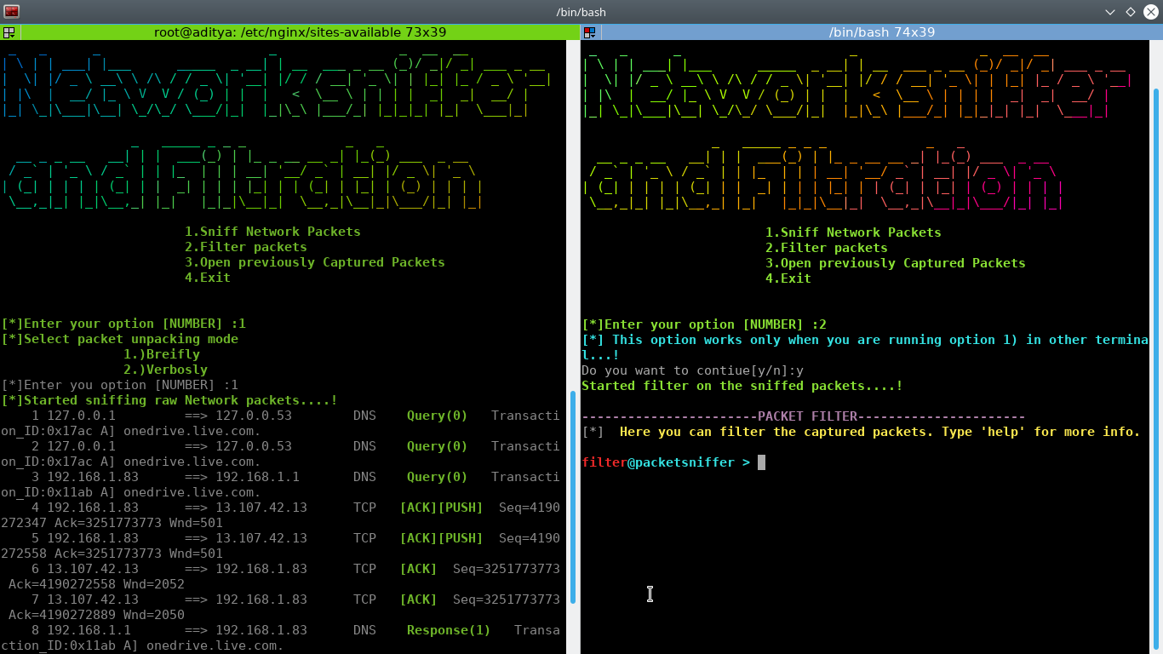

Figure 6. Packet Filtration

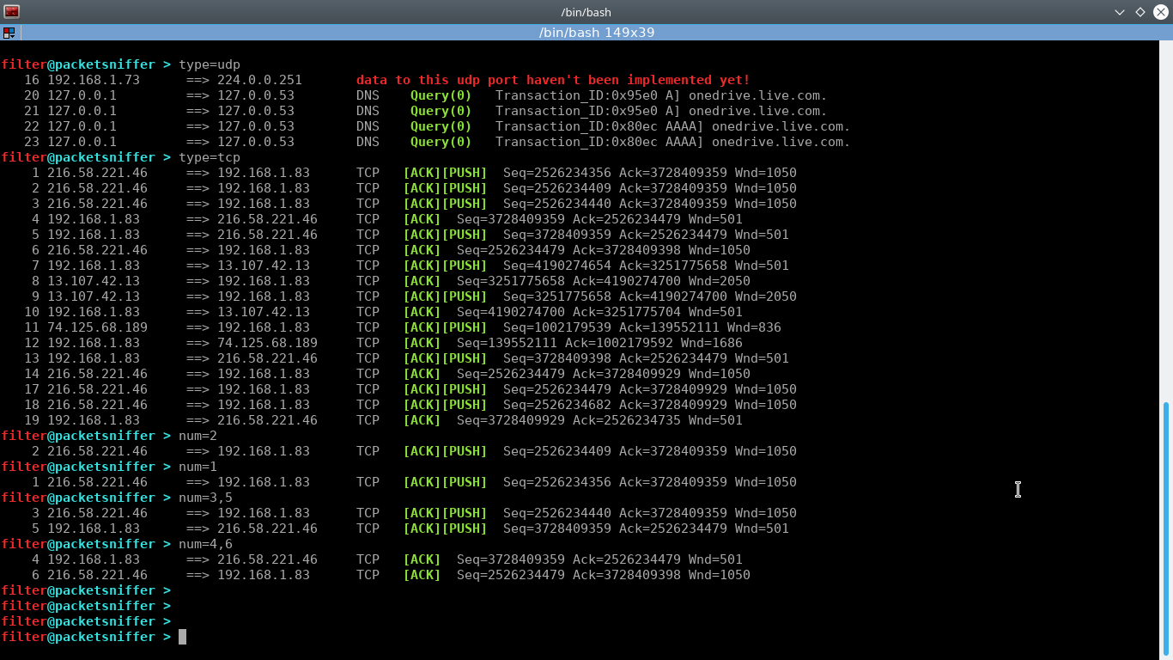

Figure 7. Packet Filtration example

- System Requirements:
- CPU: Minimum 256 MB RAM, 1GB free HDD space
- Operation System: Linux
- Hardware: Network Interface Card

- UML Diagrams

USE CASE DIAGRAM

SEQUENCE DIAGRAM

- Schedule (PERT Chart)
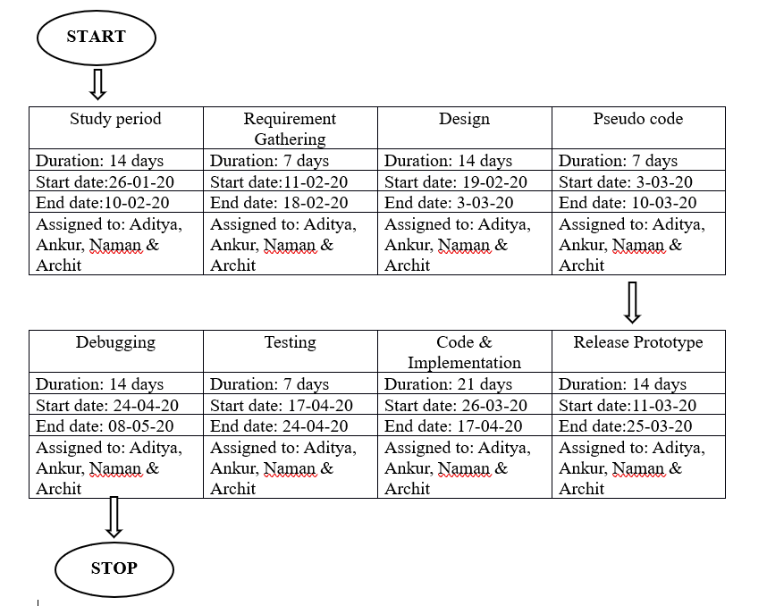

- References:

[1] Ansari, S., Rajeev, S., and Chandrashekar, H. (2002). Packet Sniffing: A BriefIntroduction. IEEE Potentials, 21(5), 17-19.

[2] Bhandari, A. and Ailawadhi, A. (2017). Literature Review on an Approach to Detect Packets Using Packet Sniffing.Journal of Network Communications and Emerging Technologies [online] Available from <www.jncet.org> [June 2018]

[3] Magers, D. (2002). “Packet Sniffing: An Integral Part of Network Defense”,May 09, 2002 SANS Institute 2000 – 2002.

Plagiarism Report

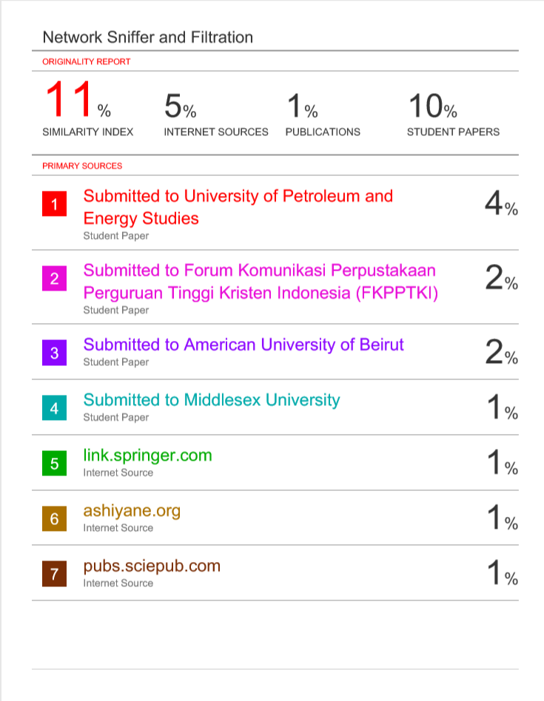

Confirmation from Mentor – Mr. Vishal Kaushik

